✅ Types of Numeral Adjectives
# Source: AI Source: Provided by: [Data Path: Persons Table -> ID Column: 1, Name_En Column: Motasem Essam] -> From: [Chatgpt (GPT-4-turbo)] on [7/27/2025]
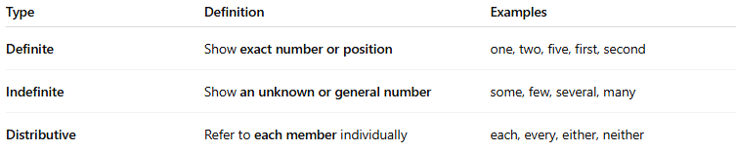
Type | Definition | Examples
Definite | Show exact number or position | one, two, five, first, second
Indefinite | Show an unknown or general number | some, few, several, many
Distributive | Refer to each member individually | each, every, either, neither

